ISYS2120 Sem2, 2025
Assignment 2 Group Report

Group code:
CC10-Team 03

Group members:
Haochen Liu SID: 540243105
Tingrui Chen SID: 540233036
(Do not edit the format of this cover sheet!)

Part A
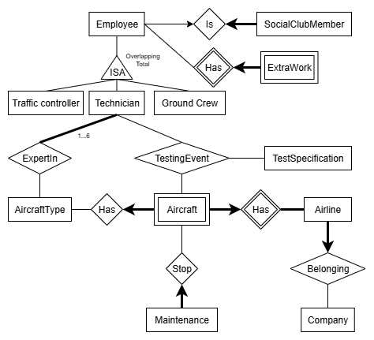

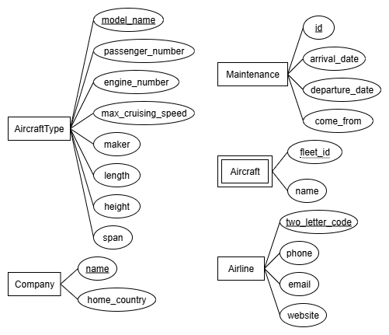

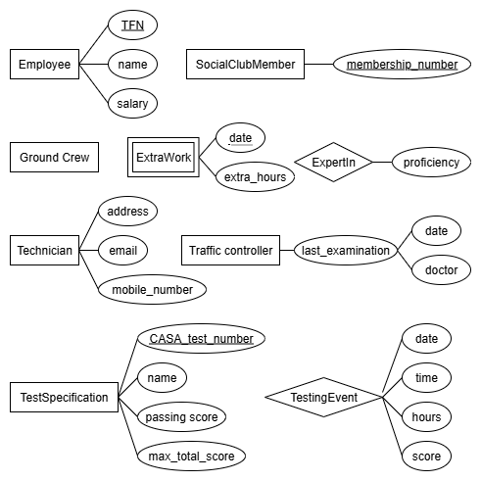

Part B:
Here are the assumptions we made in our ER Diagram Design:
First we assumed that a Company may exists even if it does not own any Airlines. So that’s why we drew a thin line with no arrows on the Company side of the Company–Airline relationship. Also in Airline-Aircraft relationship, we assumed that each Airline has at least one Aircraft as an airline cannot meaningfully exist without at least one aircraft in its fleet.
In the Aircraft-Maintenance relationship, we assumed that an Aircraft can have no maintenance events (i.e. it is newly registered at the airport), so we represented it by putting a single thin line on Aircraft side of the Aircraft-Maintenance relationship.
Our model also allows for an AircraftType to be recorded in the database without any associated Aircraft. This reflects the possibility that certain aircraft types may exist in general, but not have appeared in the airport. We used a single line to represent that on the Aircraft side of the AircraftType-Aircraft relationship.
For the Employee Entity, we think that an Employee can belong to more than one of the three roles (GroundCrew, Technician, TrafficController) and belongs to at least one. We expressed that by applying a notation of “overlapping total” constraint on the Employee entity.
For the Aircraft Entity, we didn’t treat it as a sub-entity. Instead, we treated it as a weak entity of Airline. We decomposed the RegistrationNo into two parts. The first part is the two-letter airline code, which we stored in the Airline entity. The second part is the four-letter fleet id, which we stored it in the Aircraft entity because the specification explains that each registration number is made up of a code that identifies the airline owner and a unique identifier of airline’s fleet. Here we define the “aircraft owner” as Airline. By separating the registration number into these two components, our model highlights the dependency of aircraft on airlines.

Strength:
All entities from the specification are represented in the ER Diagram. This ensures the accuracy and completeness of the conceptual description. Also, we have also explicitly expressed the multiplicities of relationships in our ER diagram by using appropriate notations such as thick or thin lines or arrows. Simultaneously, our model emphasize some key constraints mentioned in the requirements. For example, we documented the rule that each technician must be an expert in between one and six aircraft types by annotating this constraint ‘1..6’ in the ER diagram. Lastly, our ER diagram effectively uses specialization by modeling the Employee entity with an ISA relationship into the subtypes GroundCrew, Technician, and TrafficController.The specialization is annotated as “overlapping and total”, which conveys that each employee must belong to at least one subtype, while also allowing employees to hold multiple roles if required.
Limitations:
Some of the relationships cannot be expressed in the ER diagram. For instance, the ER diagram cannot explicitly express which role combinations the Employee can be when an employee belongs to multiple subtypes (such as whether Employee can be Technician and TrafficController or can be Technician and Ground Crew or anything else).
Also, the model is designed with a single airport (WSA). If the system were to be extended to multiple airports, additional entities and relationships would be required to capture the added complexity, which may influence scalability in its current form. For example, we need to add Airport entity to show multiple airports and also we need to add some relationships such as Employee–Airport (worksAt), estingEvent–Airport (occursAt) to handle specific airport activities.

